**A Machine Learning Modeling for Bitcoin Market Price Prediction based on the Long Short Term Memory**

**Abstract:**

encryption techniques are used. That can be save on the computer, without any

concerns about either theft or loss, and doesn’t spend any money being produced and

saved. It has not just the capacity of payment and circulation as same as that of gold or cash; high scale of value like a real estate or a stock as well. Due to transaction

confidentiality, however, it may be abused in tax evasions or in drug dealings.

Cryptocurrency is designed to let the individuals do freely financial dealings in P2P(peer to peer) way. Blockchain technology is a system that stores online transactional information on the block, which must be approved to be connected with an existing chain. It means the parties to a transaction exchange value with one another. Bitcoin based on Blockchain skill was invented by Nakamoto Satoshi in 2009. It realized the idea of Bit Gold and B-money and made up for faults like double expenditure[3]. Bitcoin is saved as a type of a wallet file which is given its own address, and the transactions of Bitcoin is accomplished on the basis of the address. Block is a bundle of transactional information of Bitcoin every 10 minute.

**Data Description:**

Data column information:

Open', 'High', 'Low', 'Close', 'Volume (BTC)', 'Volume (Currency)', 'Weighted Price'

Number of samples:1380

Introduction:

A virtual currency, Cryptocurrencyis dealt on the internet with no commodity money

as encryption techniques are used. That can be save on the computer, without any

concerns about either theft or loss, and doesn’t spend any money being produced and

saved. It has not just the capacity of payment and circulation as same as that of gold or

cash; high scale of value like a real estate or a stock as well. Due to transaction

confidentiality, however, it may be abused in tax evasions or in drug dealings.

Cryptocurrency is designed to let the individuals do freely financial dealings in P2P(peer

to peer) way. Blockchain technology is a system that stores online transactional

information on the block, which must be approved to be connected with an existing chain.

It means the parties to a transaction exchange value with one another. Bitcoin based on

Blockchain skill was invented by Nakamoto Satoshi in 2009. It realized the idea of Bit

Gold and B-money and made up for faults like double expenditure[3]. Bitcoin is saved as

a type of a wallet file which is given its own address, and the transactions of Bitcoin is

accomplished on the basis of the address. Block is a bundle of transactional

informationofBitcoin every 10 minute

**Algorithms:**

Long short-term memory (LSTM) is an artificial recurrent neural network (RNN) architecture[[1]](https://en.wikipedia.org/wiki/Long_short-term_memory" \l "cite_note-lstm1997-1) used in the field of [deep learning](https://en.wikipedia.org/wiki/Deep_learning" \o "Deep learning). Unlike standard [feedforward neural networks](https://en.wikipedia.org/wiki/Feedforward_neural_network" \o "Feedforward neural network), LSTM has feedback connections. It can not only process single data points (such as images), but also entire sequences of data (such as speech or video). For example, LSTM is applicable to tasks such as unsegmented, connected [handwriting recognition](https://en.wikipedia.org/wiki/Handwriting_recognition" \o "Handwriting recognition),[[2]](https://en.wikipedia.org/wiki/Long_short-term_memory" \l "cite_note-2) [speech recognition](https://en.wikipedia.org/wiki/Speech_recognition" \o "Speech recognition)[[3]](https://en.wikipedia.org/wiki/Long_short-term_memory" \l "cite_note-sak2014-3)[[4]](https://en.wikipedia.org/wiki/Long_short-term_memory" \l "cite_note-liwu2015-4) and anomaly detection in network traffic or IDSs (intrusion detection systems).

A common LSTM unit is composed of a cell, an input gate, an output gate and a forget gate. The cell remembers values over arbitrary time intervals and the three *gates* regulate the flow of information into and out of the cell.

LSTM networks are well-suited to [classifying](https://en.wikipedia.org/wiki/Classification_in_machine_learning" \o "Classification in machine learning), [processing](https://en.wikipedia.org/wiki/Computer_data_processing" \o "Computer data processing) and [making predictions](https://en.wikipedia.org/wiki/Predict" \o "Predict) based on [time series](https://en.wikipedia.org/wiki/Time_series" \o "Time series) data, since there can be lags of unknown duration between important events in a time series. LSTMs were developed to deal with the [vanishing gradient problem](https://en.wikipedia.org/wiki/Vanishing_gradient_problem" \o "Vanishing gradient problem) that can be encountered when training traditional RNNs. Relative insensitivity to gap length is an advantage of LSTM over RNNs, [hidden Markov models](https://en.wikipedia.org/wiki/Hidden_Markov_models" \o "Hidden Markov models) and other sequence learning methods in numerous applications.[*[citation needed](https://en.wikipedia.org/wiki/Wikipedia:Citation_needed" \o "Wikipedia:Citation needed)*]

The advantage of an LSTM cell compared to a common recurrent unit is its cell memory unit. The cell vector has the ability to encapsulate the notion of forgetting part of it's previously stored memory, as well as to add part of the new information. To illustrate this, one has to [inspect the equations](https://theaisummer.com/understanding-lstm/" \l "lstm-long-short-term-memory-cells) of the cell and the way it processes sequences under the hood.

**Steps for Deep Learning Algorithms:**

1. Install Anaconda Latest Version
2. Open anaconda Prompt
3. Conda create -n tf python=3.7
4. Conda activate tf
5. Install require softwares

**t**ensorflow==1.14.0

ipykernel==5.3.4

scikit-image==0.17.2

scikit-learn==0.23.2

pandas==1.1.1

matplotlib==3.3.1

Keras==2.3.1

Pillow==7.2.0

plotly==4.10.0

opencv-python==4.4.0.42

spacy==2.3.2

lightgbm==3.0.0

mahotas==1.4.11

matplotlib==3.3.1lightgbm==3.0.0

mahotas==1.4.11

nltk==3.5

matplotlib==3.3.1

xgboost==1.2.0

Jupyter

1. Activate environment for jupyter notebook(For execute the in jupter notebook)

python -m ipykernel install --user --name=

1. Goto project Directory
2. Python final.py

Note: For Text related project. Need to Download

1. Open anaconda Prompt
2. Python
3. Import nltk
4. Nltk.download()

Execution Steps:

1. Open Anaconda Prompt
2. Conda activate tf
3. Goto Project Directory
4. Python final.py

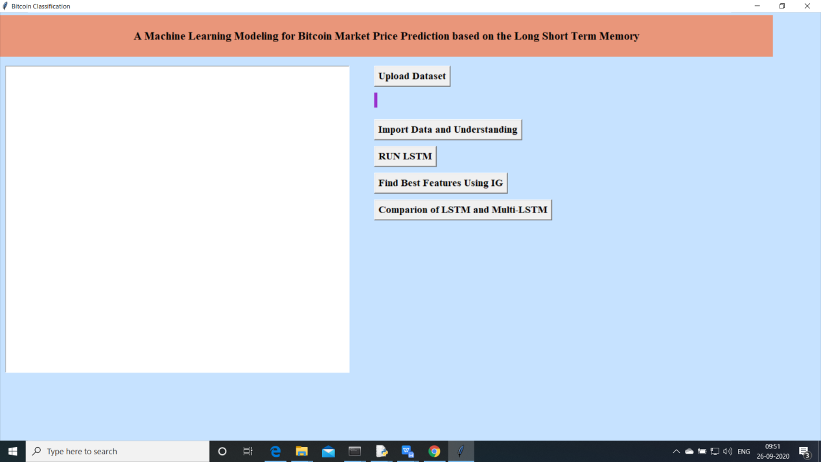

Above screen will be opened.

1. Now upload the data

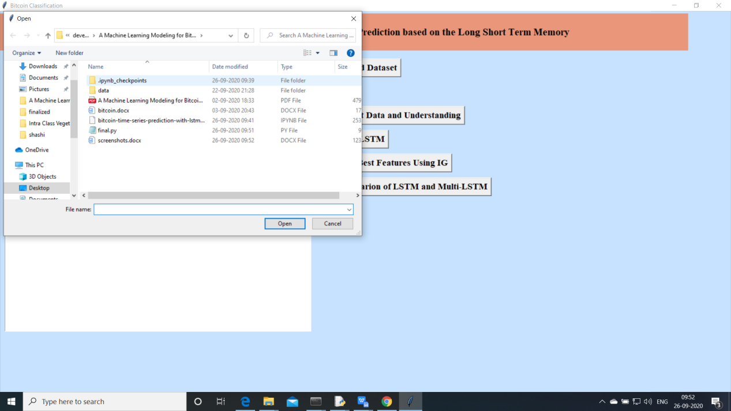

Selecte the data.csv file from data folder

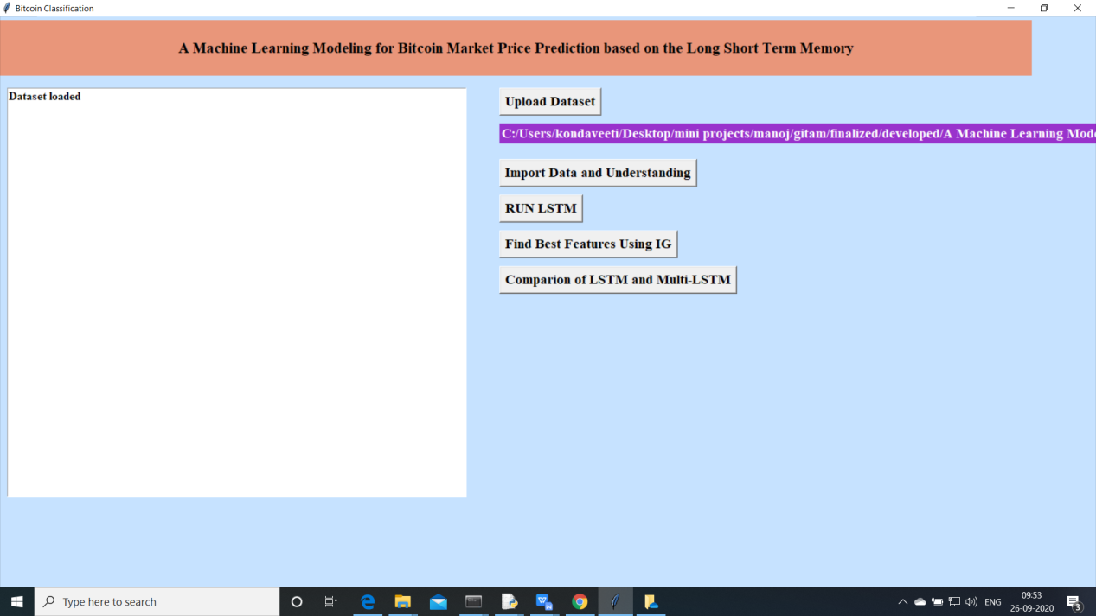

Data will be upload and filename will be shown on the label path

1. Click on Import data and Understanding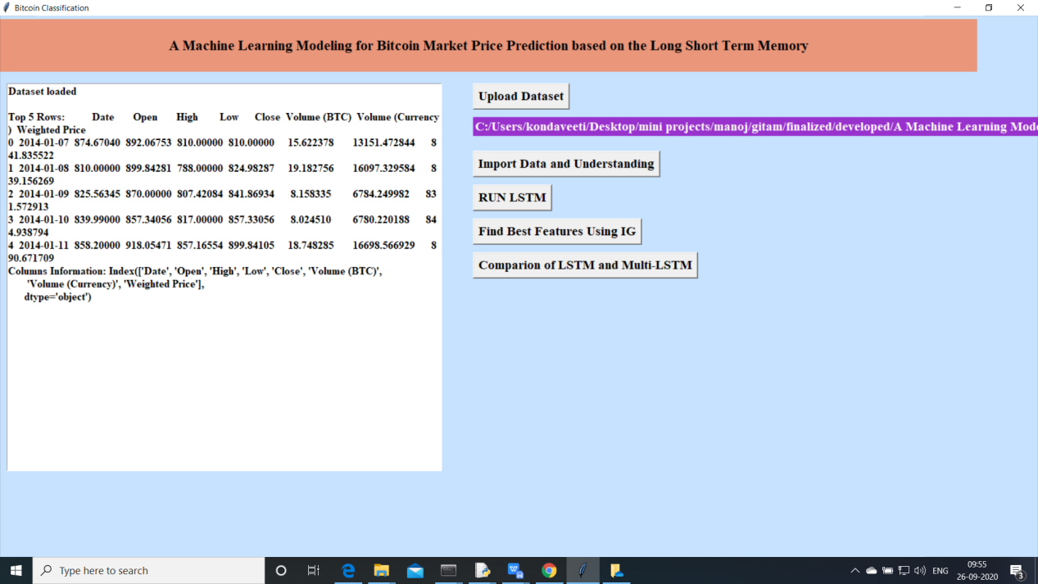

Data is read using pandas and basic information will be displayed on the screen and data is preprocessedd

1. Now Click on “Data Preprocess”

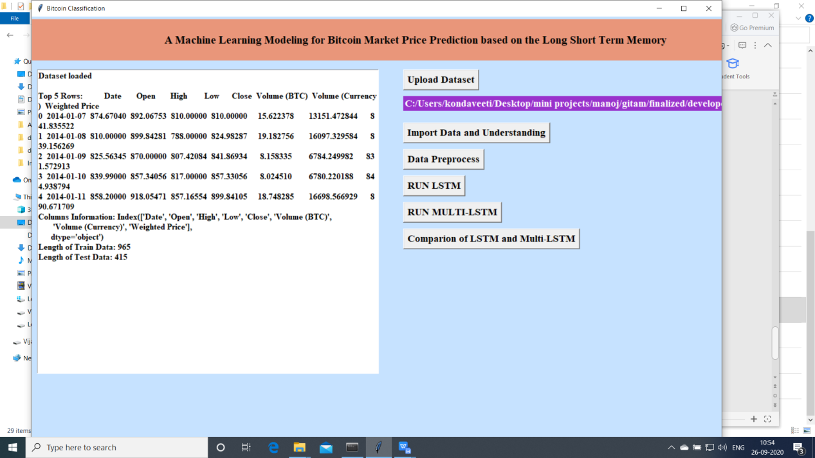

**Data Preprocess will be done in the above and we will split the data into train and test**

1. **Now click on “RUN LSTM”**
2. 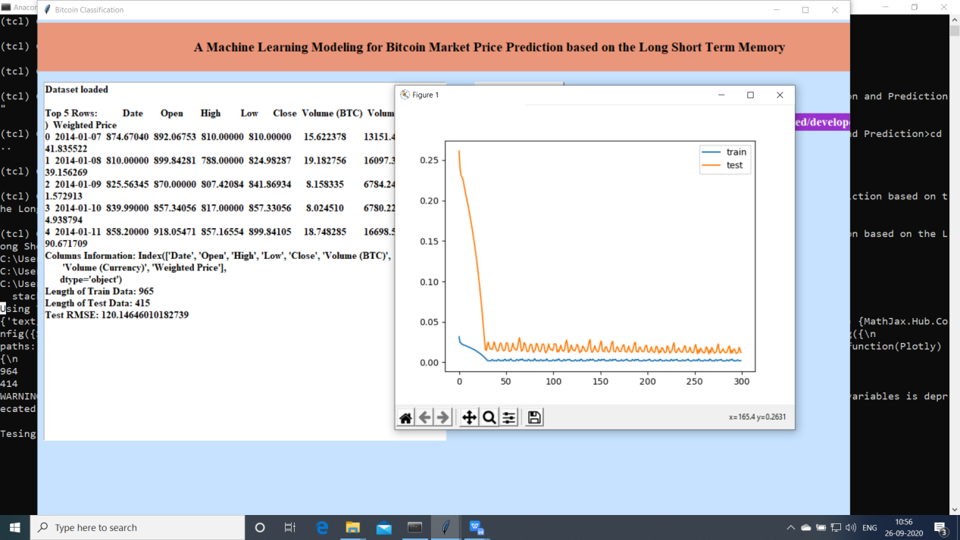

ALSTM will be strained using train data and will predict using test data and graph of trained will be shown

RMSE value:120

1. Click on “Run MULTI LSTM”